Week 3

Spring Core and Maven

Exercise 1:

Configuring a Basic Spring Application

1. Set Up a Maven Project:

Archetype: maven-archetype-quickstart

Group Id: com.library

Artifact Id: LibraryManagement

1. Add Spring Core Dependencies:

<dependencies>

<!-- Spring Core -->

<dependency>

<groupId>org.springframework</groupId>

<artifactId>spring-context</artifactId>

<version>5.3.36</version>

</dependency>

</dependencies>

3.configure aaplicationContext.xml

<?xml version="1.0" encoding="UTF-8"?>

<beans xmlns="http://www.springframework.org/schema/beans"

xmlns:xsi="http://www.w3.org/2001/XMLSchema-instance"

xsi:schemaLocation="http://www.springframework.org/schema/beans

http://www.springframework.org/schema/beans/spring-beans.xsd">

<bean id="bookRepository" class="com.library.repository.BookRepository"/>

<bean id="bookService" class="com.library.service.BookService">

<property name="bookRepository" ref="bookRepository"/>

</bean>

</beans>

4.Create Repository and Service Classes

BookRepository.java

package com.library.repository;

public class BookRepository {

public void getBookList() {

System.out.println("Fetching list of books from repository...");

}

}

BookService.java

package com.library.service;

import com.library.repository.BookRepository;

public class BookService {

private BookRepository bookRepository;

// Setter method for DI

public void setBookRepository(BookRepository bookRepository) {

this.bookRepository = bookRepository;

}

public void showBooks() {

bookRepository.getBookList();

}

}

5. Create Main Class to Test:

package com.library;

import com.library.service.BookService;

import org.springframework.context.ApplicationContext;

import org.springframework.context.support.ClassPathXmlApplicationContext;

public class MainApp {

public static void main(String[] args) {

ApplicationContext context = new ClassPathXmlApplicationContext("applicationContext.xml");

BookService bookService = (BookService) context.getBean("bookService");

bookService.showBooks();

}

}

6. Run the App in VS Code

Right-click on MainApp.java → **Run Java**

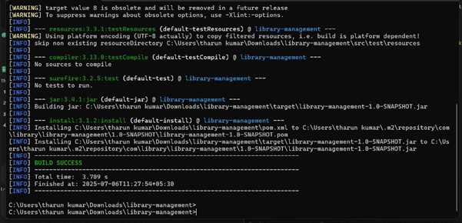

Exercise 2: Implementing Dependency Injection

Step 1: Modify applicationContext.xml

<bean id="bookRepository" class="com.library.repository.BookRepository"/>

<bean id="bookService" class="com.library.service.BookService">

<property name="bookRepository" ref="bookRepository"/>

</bean>

->> property name="bookRepository" matches the **setter** method in your BookService class.

Step 2: Update BookService.java

package com.library.service;

import com.library.repository.BookRepository;

public class BookService {

private BookRepository bookRepository;

// Setter for Spring to inject dependency

public void setBookRepository(BookRepository bookRepository) {

this.bookRepository = bookRepository;

}

public void showBooks() {

bookRepository.getBookList(); // Will call repository logic

}

}

Now Spring can inject the dependency using XML configuration.

Step 3: Test with MainApp.java

package com.library;

import com.library.service.BookService;

import org.springframework.context.ApplicationContext;

import org.springframework.context.support.ClassPathXmlApplicationContext;

public class MainApp {

public static void main(String[] args) {

ApplicationContext context = new ClassPathXmlApplicationContext("applicationContext.xml");

BookService bookService = (BookService) context.getBean("bookService");

bookService.showBooks(); // Output: Fetching list of books from repository...

}

}

Exercise 4: Creating and Configuring a Maven Project

**Step 1: Create a New Maven Project Named**

LibraryManagement

**Step 2: Add Spring Dependencies**

<dependencies>

<!-- Spring Core Context -->

<dependency>

<groupId>org.springframework</groupId>

<artifactId>spring-context</artifactId>

<version>5.3.33</version>

</dependency>

<!-- Spring AOP -->

<dependency>

<groupId>org.springframework</groupId>

<artifactId>spring-aop</artifactId>

<version>5.3.33</version>

</dependency>

<!-- Spring WebMVC -->

<dependency>

<groupId>org.springframework</groupId>

<artifactId>spring-webmvc</artifactId>

<version>5.3.33</version>

</dependency>

</dependencies>

Step 3: Configure Maven Compiler Plugin

Still in pom.xml, add this inside <build>:

<build>

<plugins>

<plugin>

<groupId>org.apache.maven.plugins</groupId>

<artifactId>maven-compiler-plugin</artifactId>

<version>3.10.1</version>

<configuration>

<source>1.8</source>

<target>1.8</target>

</configuration>

</plugin>

</plugins>

</build>

